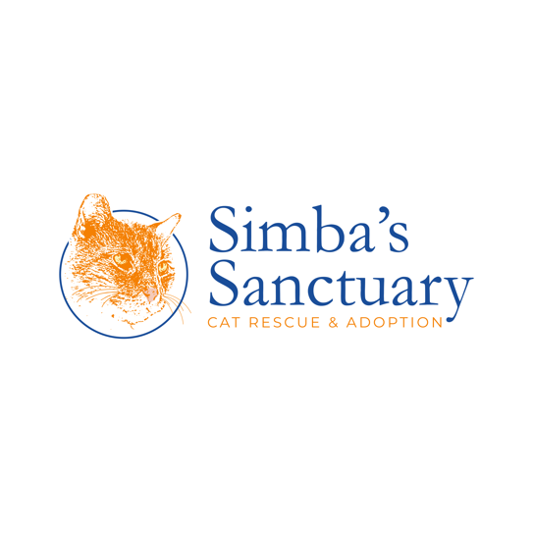

ANIMAL SURRENDER FORM
SIMBA’S SANCTUARY
151 E. Main Street, NJ 07446
_____________________________________________________________________________________

By signing this form, I state that I am the owner of the animal(s) who is/are the subject of this Animal Surrender Form, hereinafter referred to as “the animal.” To my knowledge, no other person has any right to this animal. I hereby surrender all rights to the animal. I understand that once I relinquish the animal, the animal will not be available to be returned. I have read and understand the terms of this Animal Surrender Form.
Name (Printed): _______________________________________________________________
Signature: ____________________________________________________________________
Date: _________/___________/____________

Animal Information:
Name: _________________________ Age: ___________________________
Previous Owner: _________________ Color Coat: __________________________
Animal Type: ______________________ Years Owned: __________________________
Spay/Neuter: ____________________ Last Vet Visit: _________________________
Weight/Size ______________ Sex:__________________
Indoor/outdoor: _________________ Current Vet: _______________

